

Lab 7. Create a Web Service
In this lab, you will be utilizing the Teiid Designer and JBDS to create a Web Service. It should be noted that this lab is not a guide on Web Services or how or when to use them. Rather, this is an instructional approach for some of the advanced capabilities of Teiid Designer.
To begin, right-click on the All_Customers.xmi model in the FederatedDataLayer folder. This is indicated in the illustration below.
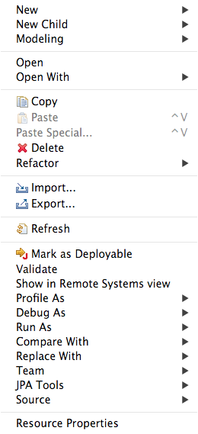
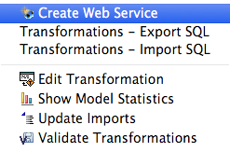

Choose Modeling → Create Web Service. This will bring up the following wizard.
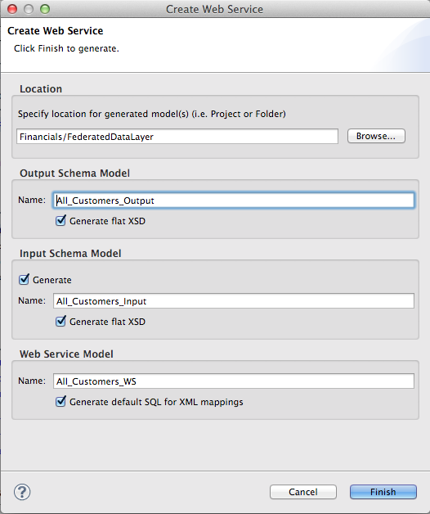

In order to keep things organized, be sure to select “Browse” and select the WebServices folder we created in an earlier lab. This will drop all web service artifacts within this folder. Then, click “Finish”. If the generation was successful, the following result will occur.
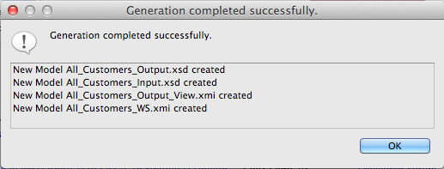

The generated Web Service will open after clicking “OK”. Your Teiid Designer view should resemble that below.
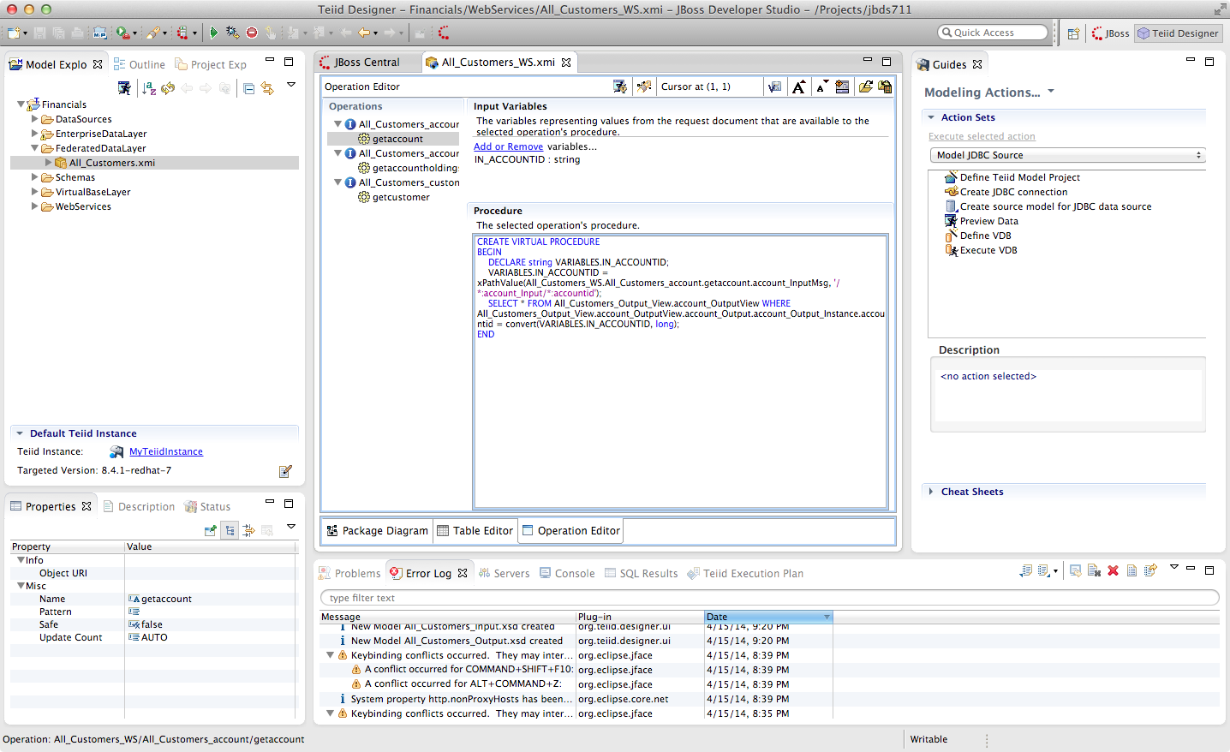
If not selected, be sure to click on the “getcustomer” operation as indicated below.
With the getcustomer operation highlighted, click the “Running man icon with a diamond T”. This icon is located across the top of the All_Customers_WS.xmi view and to the right of the Operation Editor. Click this icon to bring up the following window.
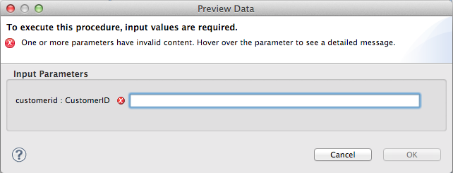

When initially opened, the customerid : CustomerID field will be blank. Enter in the value CST01033. Then, click OK.

Upon inspection of the Result1 tab reveals the XML output of the Web Service invocation as indicated below.
<?xml version="1.0" encoding="UTF-8"?>
<account_Output:customer_Output xmlns:account_Output="http://www.metamatrix.com/account_Output" xmlns:xsi="http://www.w3.org/2001/XMLSchema-instance">
<customer_Output_Instance>
<customerid>CST01033</customerid>
<firstname>Alexander</firstname>
<lastname>Franken</lastname>
<middlename>Horst</middlename>
<streetaddress>Berliner Platz 85</streetaddress>
<streetaddress2 xsi:nil="true"/>
<city>Munich</city>
<stateprovince xsi:nil="true"/>
<postalcode>80806</postalcode>
<country>Germany</country>
<phonenumber>0890877435</phonenumber>
</customer_Output_Instance>
</account_Output:customer_Output>

Congratulations, you have completed Lab #7.

